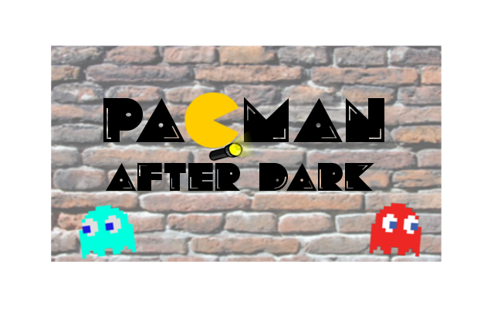

PACMAN after dark is a delightful spin on the arcade classic. Where the classic was a fast-paced race to eat all the dots, and not being eaten by the “ghosts” in the process, PACMAN after dark playfully implements an element of stealth to the original. The player will navigate a dark maze, armed only with a flashlight, and must attempt to eat all the shiny dots, without becoming a victim to the maze’s haunting.

Player(s): 1.

Keys: The arrow-keys will control where you go in the maze.

Time: ~5 minutes.

Goal: Eat all the shiny dots.

Enemies: The ghosts that roam the maze will chase you, should you encounter them, so you must move cautiously. If they chase you, try to outrun them and hide.

Creators: Tamas, Mads, Martin, Sarah, & Marie-Louise